Acute Kidney Injury

Warning Algorithm

Best Practice Guidance

Publication date 01.12.14
Revised 01.05.2018
Review date 01.05.2020

Acute Kidney Injury Warning Algorithm
Best Practice Guidance

Review date May 2020

Table of Contents

Subject Page No
1. | Introduction | 2
2. | Terminology | 2
3. | Installation and testing | 3
4. | AKI warning stage test result | 3
5. | Communicating AKI warning test result to clinicians (‘alerting’) | 4
6. | Excluding results from certain locations | 5
7. | Multiple patient records | 6
8. | Time and date issues | 6
9. | Reducing false positive alerts | 6
10. | Setting up links with UK Renal Registry | 7
11. | Actions to support the introduction of electronic detection | 7
12. | Recommendation to use enzymatic creatinine | 7
13. | Point of care analysers | 8
14. | On-going quality control, Laboratory Quality Assurance | 8
15. | Advice to measure the impact | 8
16. | Evidence generation, sharing learning, algorithm review –
a national approach to this |  | 8
Acknowledgements |  | 9
Appendix A – AKI Warning Algorithm |  | 10
Appendix B – AKI Master Patient Index Dataset |  | 11

To the best of our knowledge, the contents of this publication are in line with National Institute for Health and Care Excellence guidance relating to the management and treatment of acute kidney injury.
Professional advice should be sought before taking, or refraining from taking, any action on the basis of the content of this publication. We cannot be held responsible for any errors or omissions therein, nor for the consequences of these or for any loss or damage suffered by readers or any third party informed of its contents.
The UK Renal Registry disclaims all liability and responsibility arising from any reliance placed on the information contained in this publication by you or any third party who may be informed of its contents.

Introduction

The installation of the NHS England AKI detection algorithm should be regarded as one part of a trust-wide approach to tackle Acute Kidney Injury (AKI). The installation of the algorithm will primarily be the role of laboratory staff but other elements of the pathway will require a multispecialty approach, including appropriate clinical engagement and senior executive buy in. This Best Practice Guidance is intended to help with the installation, testing and introduction of AKI detection into clinical practice.

Terminology

Generation of an ‘e-alert’ for AKI is best regarded as a two-step process. The first stage is the detection of creatinine changes consistent with AKI, which will be delivered by the NHS England detection algorithm running in the laboratory information management system (LIMS). This will automatically compare measured creatinine values with a baseline variable on an individual patient basis to determine significant change.

It should be noted that the NHS England Patient Safety Alert (NHS/PSA/D/2014/010) refers to this detection step only. Detection of a rise in creatinine will produce a test result (AKI Warning stage) in the LIMS. The second stage of the process is the communication of AKI results to clinicians - the alerting phase of the process. As a minimum, positive AKI results will be sent to hospitals’ results reporting systems where they can be viewed by clinicians. However, depending on local resources/capabilities, you may choose to institute additional alerting pathways; this part of the process is not mandated in the patient safety alert and should be developed locally (see section 4).
Alerts
Detection

Figure 1. The two step process in generating an e-alert for AKI

It is obvious that AKI can be detected in different health care settings: this includes AKI that occurs and is detected in primary care; AKI that is present and detected on admission to hospital (often referred to as community acquired AKI in studies looking at hospitalised patients); and AKI that occurs during a hospital stay (hospital acquired AKI).

Installation and testing

The AKI detection algorithm provided by your LIMS provider should match the specification contained in the NHS England Patient Safety Alert (NHS/PSA/D/2014/010) which can be found at https://improvement.nhs.uk/documents/251/Patient_Safety_Alert_Stage_2_-_AKI_resources.pdf

After installation, the performance of the algorithm should be verified before introduction into clinical practice. Your LIMS provider should be able to supply you with a test script to allow you to do this. The purpose of the test script is not to test all functioning aspects of the AKI warning algorithm but rather to demonstrate that the principal features of the algorithm are working correctly in your local laboratory environment. Successful running of the test script does not absolve LIMS suppliers from the need to thoroughly test all aspects of the operation of the algorithm within all versions of their software; nor is it intended to validate the operation of the AKI warning algorithm outside the LIMS environment. The test script comprises four steps, each of which must be tested, and full instructions of how to do so are included. Good practice dictates that each laboratory should evaluate the test script against their own LIMS and document the results obtained. If a deviation from the expected outcome is seen, this should be notified to the LIMS provider and records maintained of all subsequent correspondence.

AKI warning stage test result

The AKI detection algorithm will produce a test result for every creatinine result that is consistent with AKI; the test result is named ‘AKI Warning Stage’. This test result will be a numerical field with up to four possible variables: null, 1, 2 or 3. The null result (indicating that AKI has not been detected) will not be reported, but results 1, 2, or 3 should be sent to your local results reporting system/patient management system and set to flag as abnormal as for all other biochemical test results.

Reporting laboratories should append a text comment to the AKI Warning Stage test results. It should be possible to set rules in the LIMS to automatically append the appropriate comment for stage 1, 2 or 3. At present, there is no standard or agreed wording and this can be configured locally. However, an example for adults (age >18 years) is included here:

Rise in creatinine may indicate Acute Kidney Injury stage x (1, 2 or 3). Please review urgently.

- AKI stage 1 is a rise of > 1.5x baseline level or of > 26 µmol/L within 48 hr or a urine output of <0.5mL/kg/h for 6 – 12 hrs.
- AKI stage 2 is a rise of > 2x baseline level or a urine output of < 0.5 mL/kg/hr for ≥12 hrs.
- AKI stage 3 is a rise of >3x baseline level or a rise of > 1.5x baseline to >354 µmol/L or a urine output of <0.3 mL/kg/hr for ≥24 hrs or anuria for ≥12 hrs.

Clinical comment: Consider drugs that may be harmful to kidneys, obstruction, hydration and infection.
Trusts are expected to identify and keep under review appropriate guidelines regarding acute kidney injury. It is recommended that guidelines on the diagnosis, investigation and treatment of AKI can be found on your organisation’s intranet.

For patients aged <18 years, AKI stage 3 is also defined as a rise in serum creatinine to >3 x the upper limit of the age-related reference range. The urine output criteria also differ for age <18 years: stage 1 is <0.5mL/kg/h for >8h; stage 2 is <0.5mL/kg/h for more than 16h; stage 3 is <0.3mL/kg/h for 24h or anuria for 12h.

The algorithm will also identify creatinine results that are elevated above the local reference range for which there are no previous creatinine values within the last 12 months to use as baseline comparators. These results should have a comment appended e.g. ‘creatinine high. ?AKI ?CKD, consider early repeat’.

Laboratories should determine from their LIMS provider how the calculated baseline creatinine value will be handled within the LIMS, and in particular whether this will be stored as a temporary variable. If it is stored as a temporary variable, then this can be added to the AKI report e.g. inclusion in the text comment that accompanies a positive AKI Warning Stage result. It can also be useful to extract the calculated baseline variable for local audit purposes.

Communicating AKI warning test result to clinicians (‘alerting’)

The AKI Warning Stage results will be sent from the LIMS to your local results reporting system or patient management system, as for all other biochemical results. Clinicians will be able to view these when they login to check patients’ results. As such, it is good practice to embed methods of results’ acknowledgement that include AKI Warning Stage results to make this process more robust.

In addition, there are other methods of alerting clinicians that could be configured locally to maximise impact and visibility of an AKI result:

Draft guidelines from the Royal College of Pathologists make the following recommendations on the telephoning of AKI results:

AKI STAGE | PRIMARY CARE | SECONDARY CARE | COMMENT
1 | B | A | All new occurrences
2 | B | A | All new occurrences. Primary care : if OOH then communication next day to GP or GP OOH
3 | B | A | Only if K > 6.0. Primary care : if OOH then communication next day to GP or GP OOH
Communication key:
A = rapid communication within 2 hours, usually by telephone
B = out of hours (OOHs) then communication within 24 hours to GP/GP OOHs service.
Reference: https://www.britishinfection.org/files/3714/6961/9936/G158-DRAFTCommCriticalUnexpectedResults-Jul16.pdf.
Development of additional alerting systems that are triggered by a positive AKI Warning Stage test result will depend on your organisation’s local resources and capabilities. There are many examples of different methods to do this, including those within patient management systems, via dedicated messaging platforms and through electronic ‘track and trigger’ patient observation systems.

PAS (Patient Administration System) link. There are examples of good practice from around the country in which positive AKI Warning Stage results generate an automatic AKI notification within a hospital’s PAS Electronic Patient Record. These notifications are temporary and are removed at the end of the hospital stay, which then allows re-notification if the patient sustains AKI during a subsequent hospital admission. There are several uses for this including real time surveillance of AKI across the hospital, and linkage to other systems such as electronic whiteboards that can then list patients in each clinical location who have had an AKI Warning Stage result.

Excluding results from certain locations

When the initial Patient Safety Alert was issued, creatinine results originating from primary and secondary care were treated as separate entities where the laboratory systems could distinguish these. If this was the case, the AKI stage was only reported on those results originating from secondary care; it should be noted that not all LIMS were capable of this distinction and the AKI stage was reported regardless of originating setting. However, with effect from March 2015 the AKI warning stage result was calculated regardless of origin. However, there remain certain clinical areas where the AKI warning stage should be excluded e.g. by supressing the results from the LIMS. These areas include:

- Renal units – to prevent chronic dialysis patients from being mis-classified as AKI. This will not prevent dialysis patients admitted to other locations from generating false positive alerts. Depending on local capabilities, other solutions to identifying dialysis patients may come from excluding patients with dialysis clinic codes, or who have specific blood test orders (if your local hospital has blood test orders that are used specifically by dialysis patients e.g. peritoneal equilibrium testing, urea kinetic modelling).

- Neonatal units – neonates are excluded from the AKI detection algorithm due to the specific nature of interpreting creatinine values in this setting.

7. Multiple patient records

NHS pathology laboratories are affected to differing extents by the problem of individual patients having multiple patient records. This has relevance as failure to reconcile multiple patient records limits the availability of previous creatinine measurements to use when calculating the baseline value. Having multiple records for individual patients is not considered good practice for many reasons beyond the scope of AKI detection, and each laboratory should ensure that they have assessed the extent of this locally and put measures in place to address this. Use of the NHS number, as the identifier, may be a practical solution if available.

8. Time and date issues

Time periods for calculating baseline are measured in both hours (initial 48hour period) and days. It is possible that your local arrangements for recording sample times may impact this and laboratories should be aware of how the algorithm is performing within the local environment (e.g. sample collection time versus laboratory received time). In addition, laboratories should check that when no sample time is recorded the algorithm still functions and that a default time value (e.g. midnight) is not automatically entered that affects the results. The NHS England test script will help with this.

9. Reducing false positive alerts

Any automated AKI detection algorithm based on serum creatinine changes will generate false positive and false negative results; it is for this reason that the result must be interpreted within the clinical context of the individual patient. You Trusts may wish to audit this and may also wish to develop exception reports that screen for such situations. Some examples may be:

- Falsely low creatinine measurements (e.g. creatinine taken from drip arm) used as baseline within 7 days

- Dialysis patients with blood samples sent from locations other than renal department

- The effect of previous AKI episodes on the diagnosis of new AKI episodes

- Action that occurs when a null creatinine result is generated. If NA or any other null field indicator is generated from the analyser, some LIMS store these results as ‘0’ and if so these data points may affect calculation of baseline value. These results need to be excluded.

- Increases of serum creatinine over 48 hours of more than 26µmol/L (but less than 50% above baseline) in stable chronic kidney disease (CKD). The within individual variation of serum creatinine is unknown in patients with this condition but the reference change value may exceed 26umol/L

10. Setting up links with UK Renal Registry

One of the actions identified in the NHS England Patient Safety Alert was to set up processes to allow AKI Warning Stage data to be extracted and sent to the UK Renal Registry to facilitate benchmarking and quality improvement. Setting up these links is outside the scope of this Best Practice Guidance, and advice regarding this aspect of the process is available separately at https://www.thinkkidneys.nhs.uk/aki/wp-content/uploads/sites/2/2016/07/Sending-data-Best-Practice-v13.pdf.

11. Actions to support the introduction of electronic detection

Prior to the launch of AKI warning test results into clinical practice, it is considered good practice to have local plans for publicity and education to raise awareness and understanding among clinicians. The impact of the introduction of AKI detection may also be enhanced by combining its introduction with other hospital wide interventions aimed at improving care for patients with AKI. These may include on-going education programmes, the introduction of AKI guidelines (which you may choose to link to the AKI warning stage test result script), AKI care bundles and delineation of local referral and network frameworks.

Clinician engagement in the development of the alerting step of the process may be valuable. A full description of these interventions is beyond the scope of this good practice guideline, but further information and examples of good practice in these areas can be found on the NHS England website https://www.england.nhs.uk/akiprogramme/aki-algorithm/

12. Recommendation to use enzymatic creatinine

Enzymatic creatinine assays are less susceptible to interference than Jaffe-based assays and are recommended in both the CKD and AKI NICE guidelines

- https://www.nice.org.uk/guidance/cg182

- https://www.nice.org.uk/guidance/CG169

For financial reasons, many laboratories use enzymatic assays for selected patients only, e.g. children, those with high bilirubin. The AKI warning may be set up for both Jaffe and enzymatic assays, but where both are in use the warning algorithm should be assay-specific.

13. Point of care (POCT) analysers

These all use enzymatic assays and if results are displayed in the electronic patient record they should clearly be shown as Point of Care Testing (POCT) results. The precision of these assays is worse than for laboratory assays, they are most widely used to screen for CKD prior to high-risk procedures, and we are not aware of data regarding their reliability for AKI detection.

14. Ongoing quality control, Laboratory Quality Assurance

The day-to-day imprecision for creatinine across all analysers within a laboratory or network should be less than 5%. All laboratories should be part of an external EQA scheme that will periodically distribute samples designed to test for AKI detection.

Prior to going live, laboratories should audit the results flagged with an AKI warning (kept blind from the requester) by manual evaluation of the patients’ creatinine results to determine the proportion of false positives. This will help detect if there are specific locations that may need to be excluded if they generate high false positive rates.
Laboratories should be aware that inspections undertaken by the United Kingdom Accreditation Service (UKAS) under ISO 15189 may require evidence of full conformity with the requirements of the patient safety notice i.e. evidence of AKI Warning Stage generation and links with the Renal Registry.

15. Advice to measure the impact

A key component of the Think Kidneys AKI programme is to incorporate the measurement of effect alongside the introduction of improvement strategies to assess efficacy and generate an evidence base as well as quality improvement. Where laboratories had pre-existing AKI algorithms, this should be documented giving dates and the algorithm(s) used. When the switch was made to the national algorithm the impact of the change should also be documented for future reference.

16. Evidence generation, sharing learning, algorithm review – a national approach to this

It is envisaged and well understood that the introduction of a national AKI detection algorithm is the start of an evolutionary process. The Think Kidneys programme wishes to publicise and share examples of good practice, to encourage measurement of effect, to promote evidence generation and to have methods of receiving and responding to feedback. One of the purposes of these processes will be to feed into a group that is scheduled to meet to regularly review the performance of the algorithm in clinical practice. This will determine if future modifications are necessary, and if so, feed into a structured process by which updates occur in a step-wise fashion and involve LIMS providers. We have therefore set up the following resources, and others will to follow:-

- Website https://www.thinkkidneys.nhs.uk/

- JISCMAIL discussion group https://www.jiscmail.ac.uk/cgi-bin/webadmin?A0=ACB-AKI-ALGORITHM&t=&X=BFE4248C17A8B4772E

If you would like to contact us, please do so at thinkkidneys@renalregistry.nhs.uk

Acknowledgements

Dr Robert Hill
Chair of Detection Workstream
Think Kidneys National Programme

Dr Nick Selby
Co-Chair of Detection Workstream
Think Kidneys National Programme

Appendix A – AKI Warning Algorithm

The algorithm below can also be viewed at the following link https://www.england.nhs.uk/akiprogramme/aki-algorithm/

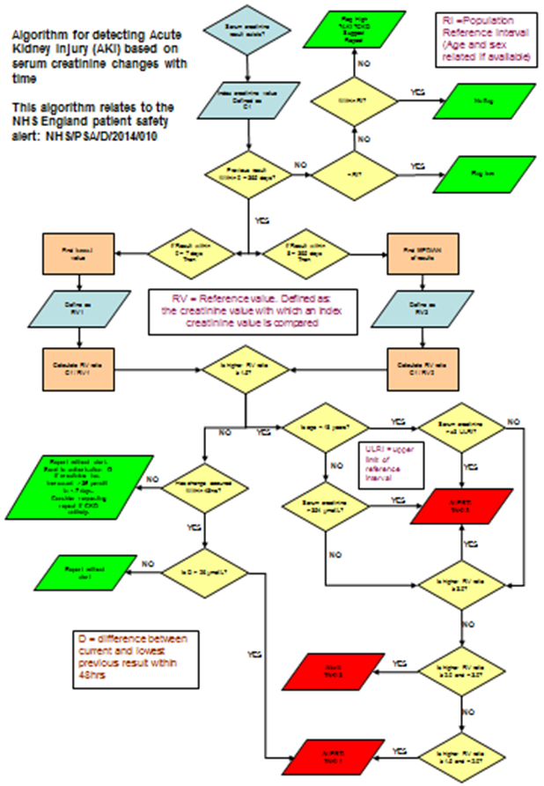

Appendix B – AKI Master Patient Index Dataset

AKI Data Specification for reporting to UK Renal Registry

This can be viewed online at:

Sending data best practice

