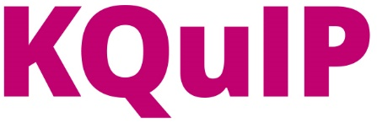

Improving the Journey to Home Dialysis
Gloucestershire Hospitals NHS Foundation Trust and Baxter Healthcare Limited

A summary of the quality improvement we needed to address
Inconsistency and uncertainty exist with the patient pathway in many renal units. This may be one of the factors contributing to the lack of adherence to national guidelines and many renal units having a low uptake of home dialysis therapies, below the targets set in the guidelines.

To improve the patient experience, avoid duplication of work and ensure patients receive the most appropriate therapy, clearly defined care pathways and the empowerment of the multidisciplinary team are essential.

This challenge was identified by the renal team at Gloucestershire Hospitals NHS Foundation Trust, who had a department vision to increase the patient population on home dialysis therapies from 14.45% to 23% by March 2016 (CQUIN target agreed with CCG).

What did you want to achieve with your QI initiative?
- To increase the prevalent population of dialysis patients receiving home dialysis therapies to 23%
- To ensure end stage renal failure patients receive the most appropriate form of Renal Replacement Therapy (RRT) at each stage of the pathway and are given regular opportunities to make informed decisions about their care
- Involving and motivating the multi-disciplinary team to agree the target statement and develop a ‘can do’ attitude and commitment in the unit
- To achieve sustainable change, with quality improvement as the new way of working rather than something added on to routine clinical care

Who was involved in your work?
The quality improvement initiative involved a multi-disciplinary team made up of all specialties within the department working in and near the process to achieve sustainable change: the Divisional Manager, Matron and Clinical Director, consultants, specialist nurses, ward nurses, pharmacists, dietitians and commissioners.

The process is based on the two key philosophies of lean methodologies: respect for people,
and empowering them to do their job, and elimination of waste to maximise flow
The project commenced with a full day workshop with the multi-disciplinary team from Gloucestershire Hospitals NHS Foundation Trust renal team, to map the current pathway for patients starting Renal Replacement Therapy.

Following the initial workshop the full pathway was displayed in the Renal Unit to engage and involve the wider renal team who were all actively encouraged to engage in the process.
All events were facilitated by an Evolving Health Manager from Baxter Healthcare Limited.

What did you do?
The project utilised lean methodologies, to support the Renal Unit goal of increasing the number of patients receiving home dialysis therapies, as per the flowchart below

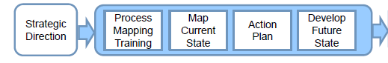
The patient journey was mapped, from referral to the renal team to six months on dialysis therapy.
It began with defining the problem and target statement to be addressed and a review of existing clinical and performance data to show the unit baseline position.
A one day workshop was held in September 2015, with the multi-disciplinary team, to process map the current patient pathway. This enabled the team to identify points of value and waste in the patient journey onto dialysis. Prior to the workshop, all participants were sent a brief outline of lean methodologies and asked to complete a worksheet based on the “Eight Wastes”.

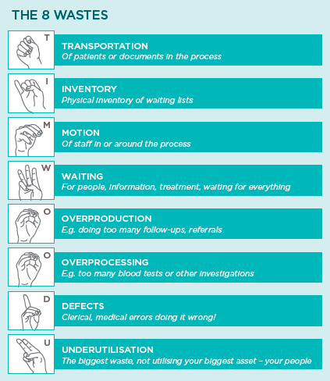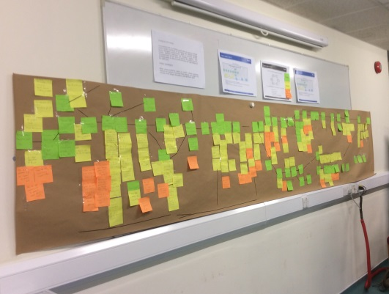

The team then split into four working groups to focus on the four key areas identified as bottlenecks in the current state pathway; low clearance, pre-dialysis, access and uptake and retention of patients on home therapies. The working groups developed action plans to address the issues identified and in so doing developed the future state pathway.

The team was encouraged to be thorough, to eliminate non-value added activities rather than optimising them and also to do some background reading to checking whether a clinical change is feasible, referencing national policy and guidance where applicable.

When a team was unable to reach consensus on any point within the pathway, members were asked to reach consensus through focusing on what would be the most sustainable and best approach for the patient.
The teams reconvened into the full MDT, once per month to review progress, for six months after the initial workshop. Between each meeting, the working groups communicated regularly in person and virtually.
The full MDT team met in September 2016, to review progress and celebrate success. The team are to meet quarterly to update on sustainable Quality Improvement

Quality Improvement in uptake of home therapies has been demonstrated and measured through developing run charts and SPC charts to monitor patient numbers receiving Peritoneal Dialysis and Home Haemodialysis.

What was the outcome of your QI work?
- The prevalent patient population on home dialysis therapies has increased from 14.45% (September 2015) to 18% (October 2016).

- The introduction of additional training for all staff on home dialysis therapies.

- Identifying the need for an additional nursing post in pre-dialysis, which has been approved and successfully recruited to.

- The planned introduction of a medical insertion programme for PD catheters, which was aligned within the pathway and fully supports the wider service improvement initiative.

- The introduction of new technology that has driven efficiencies in clinic time and home visits for PD patients.

What impact have changes had on patient care?

Positive impact on patient care as well as improved staff morale with increase in home therapy’s number over the last 12 months.

On patient care:
- Improve patient choice
- Patient safety-reduced hospital acquired infection from temporary HD lines.
- Decrease length of stay-medical PD catheter insertion is now done as day case procedure
- Increased patient satisfaction-ability to do dialysis at home thereby not relying on hospital transport

What did you learn from your QI work?
Realistic expectations on the time it takes to change, the initial target to increase home therapies to a target level within 6 months did not allow enough time for the changes to be implemented
Regular communication to share all the incremental changes achieved by all members of the team, to maintain motivation, celebrate successes and challenge process changes that were not effective.

9. Describe the whole process in three words
Team
Focus
Can-do attitude

Contact details for more information about your QI project
Ann Cole, Evolving Health Manager, Baxter Healthcare Limited
Ann_cole@baxter.com
Tel: 07788 359934

