PD Training

Manual

For Assisted APD

A Guide

For Patients

2016

Contents.

1
PD Training 1
Manual 1
For Assisted APD 1
A Guide 1
For Patients 1
2016 1
Introduction. 4
PD--- What it does and how it does it! 5
PD has two effects on the body: 5
Diffusion. 6
Ultrafiltration. 6
Your Future on Dialysis. 7
Risk of Infection. 8
Exit Site and Catheter Care. 9
Procedure for Redressing your Exit Site 10
Catheter Leakage or Damage. 11
Possible causes for exit site leaks 11
Drainage Problems. 12
Peritonitis. 13
Signs & Symptoms of Peritonitis: 13
What to do if you suspect Peritonitis. 14
If you can go home. 14
If you need to stay in Hospital. 14
Causes of Peritonitis. 15
Blood Stained Fluid. 16
Fluid Balance. 17
Fluid Overload. 18
Signs & Symptoms. 18
Causes of Fluid Overload. 18
Action. 18
Glucose Removes Excess Fluid 19
Dehydration. 20
Signs & Symptoms. 20
Causes of Dehydration. 20
Action. 20
Dry / Target Weight. 21
Contamination. 22
Guide to Motor Insurance for dialysis patients 23
Motor Insurance. 23
Ordering of Stores. 24
Disposal of Rubbish 25
Aftercare. 26
Tests and Investigations. 27
Blood Tests. 27
Swabs. 27
U.K.M. 27
P.E.T. 27
Lifestyle, Hobbies, Sex and Future 28
Conclusion. 30
Questionnaire. 31

Introduction.

This training manual has been written to help you learn how to carry out and manage your own PD treatment as well as discussing a few problems that you may come across and how to deal with them.

It should be used to help you learn things during your training period and then it can be taken home for you to use for reference purposes.

Here are some phone numbers that you may find useful:

ROYAL SHREWSBURY HOSPITAL | (01743) 261000
WARD 28 Nephrology | (01743) 261178 anytime
PD OFFICE | (01743) 261092 between 9 am to 5 pm
RENAL UNIT | (01743) 261055
DIETICIAN | (01743) 261139
RENAL TECHNICIAN | (01743) 261054

You can speak to someone at any time of the day or night so if you are worried -
ring us.

PD--- What it does and how it does it!

CAPD stands for Continuous Ambulatory Peritoneal Dialysis

APD stands for Automated Peritoneal Dialysis

PD has two effects on the body:

- It lowers the high levels of waste products that are in the bloodstream caused by chronic renal failure.

- It can remove excess fluid from the body.

This works by the following two processes:

- Diffusion.

- Ultrafiltration.

Diffusion.

This is the process whereby the PD fluid in your abdomen draws waste products from the blood stream, through tiny holes or 'pores' in the peritoneum therefore lowering the waste product levels in the blood.

Peritoneum.

Blood containing waste products.
Dialysis fluid.
Dialysis fluid.
Blood.

Ultrafiltration.

This process allows fluid to be drawn from the blood, across the peritoneum and into the PD fluid. The higher the concentration of glucose in the fluid, the more fluid will be drawn across the membrane from the body.

Dialysis Fluid.
Dialysis Fluid.

Blood Side.

Blood Side.

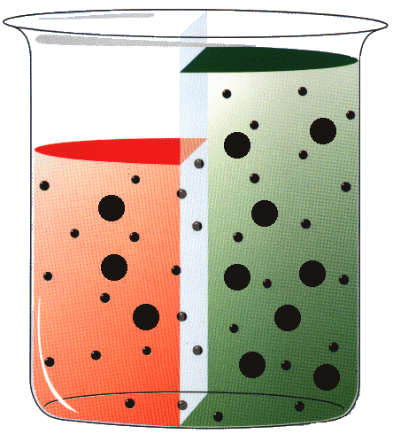
Water.
3.86 % Glucose
Water.
3.86% Glucose

To allow these processes to go on in your body continuously, the PD fluid in your abdomen needs to be replaced with fresh fluid on a regular basis. How often it is changed is an individual requirement. On average it is four times daily. The process where the fluid is changed is called an “exchange”, and takes around 30 minutes. Alternatively a machine by your bedside will put the fluid in and out of your abdomen whilst you sleep.

Your Future on Dialysis.

At the present time PD is playing a huge part in your life and is probably in your thoughts almost constantly. This is because it is new to you and you are in the process of learning about it.

You will always have to pay attention to your PD and take care when doing your connections, but in a few weeks you will have settled down into a routine and will find that you can resume your usual daily activities, hobbies and employment with minimal disruption.

The length of the training period varies from one person to the next - there is no set time limit. It will continue until you feel confident to manage some of your own treatment at home and when the PD staff and medical team are happy that you can cope.

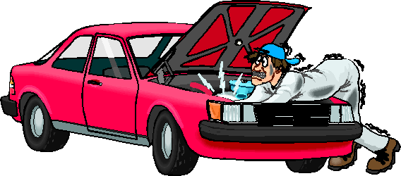

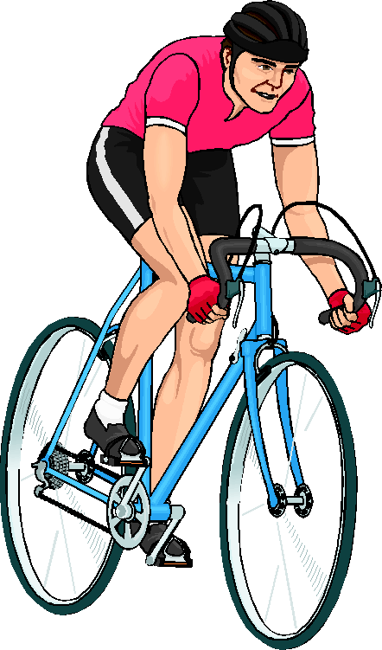

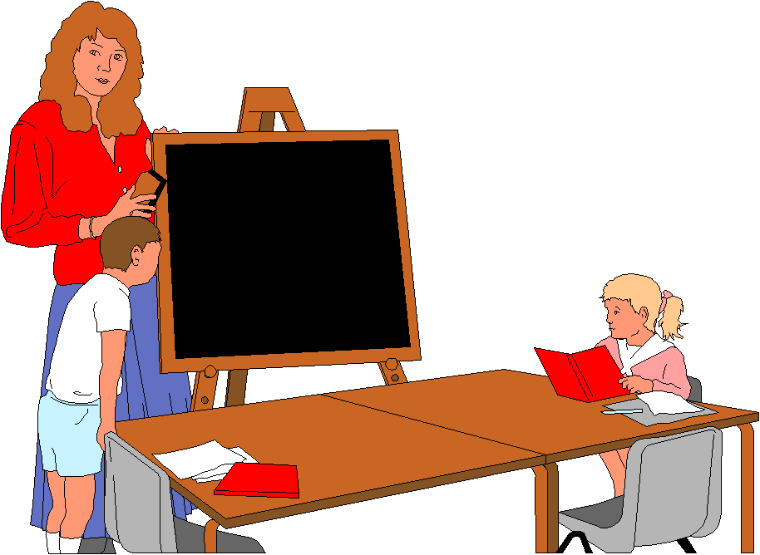

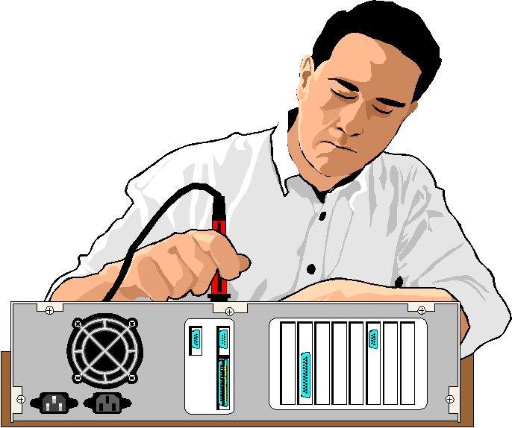

Risk of Infection.

The biggest risk of PD is infection which can occur around the exit site or within the abdomen (called peritonitis) or both.

Infection is caused by bacteria which are everywhere in the atmosphere, on objects around you as well as on your skin. Normally they don't cause any problems but if they enter your abdomen, this will lead to infection.

There are many ways in which the risk of infection can be reduced and these will be taught to you during your training period. The following are some general points to reduce the risk of infection.

It is important to maintain a high level of personal cleanliness. Showering is recommended either daily or alternate days.

It is also important to keep your `PD area' clean and tidy. Regular tidying, vacuuming and dusting of that area is recommended.

Hand washing is very important also. During your training you will be taught a particular hand wash which you should perform as taught. Nails should be kept short and clean (to prevent build up of bacteria under nails) and skin should be clean and intact. You will probably find that the soaps and handrubs that are used will dry out the skin on your hands. To prevent your skin chapping and becoming sore, handcream is recommended after each exchange.

The bowl used for hand washing should be used only for PD and should be washed and dried thoroughly after each exchange, then stored upside down (to prevent dust settling in it.) Alternatively you can wash your hands in the bathroom if nearby.

If you have a sink in the room to use for your PD it should be washed daily to prevent the build up of bacteria. When washing your hands take care to avoid touching the sink or taps (otherwise bacteria would be transferred on to your hands).

Animals should not be allowed into the room where PD takes place.

Exit Site and Catheter Care.

Your skin is the body's natural protection against bacteria entering the body. Any break in the skin is an area prone to infection. Your exit site is one such area. It is very important that you make sure your exit site stays infection free otherwise bacteria may track down your catheter and cause infection within your abdomen called Peritonitis. The following points will reduce the risk of exit site infection:

- Keep exit site dry. Redress it immediately after a shower or if it becomes wet any other way e.g. swimming, heavy rain etc.

- Keep your catheter in a secured position at all times to allow skin to heal around the catheter. If the catheter is constantly moving around it will damage the exit site.

- Avoid pulling or twisting your catheter which will damage the exit site and let bacteria enter. Pay particular attention to securing your catheter when contemplating physical activities such as sport, sex etc.

- Redress exit site on alternate days if it is infection free. Examine it for signs of infection e.g.

REDNESS

PUS OR DISCHARGE
SORENESS.

- Act promptly if you suspect infection. Phone the PD nurses who will arrange for a swab of your exit site which will show if there is infection present.

- If infection is present the doctor will prescribe a course of antibiotics for you to take as well as some ointment to put on your exit site.

- In some cases exit site care will be carried out by healthcare workers.

Remember - If you think it’s infected then get
it inspected!!

Procedure for Redressing your Exit Site

- Close doors, windows and switch off fans. Allow dust to settle for one hour after vacuuming, bedmaking or dusting.

- Gather equipment…..

- SURFACE WIPE
- GAUZE
- ALCOHOL HAND RUB
- SPONGE WIPE
- MEPORE DRESSING 9 x 15 cms
- ROLL OF TAPE

- Clean surface with a Surface Wipe.

- Prepare tape, open dressing, gauze and sponge wipe.

- If able to shower, leave dressing intact and place Miniset into a new plastic bag, taping it upside down to abdomen.

- After showering, dry body as usual and remove plastic bag.

- If not showering, arrange clothing to allow you to see exit site.

- Wash hands as taught and dry thoroughly. Apply alcohol handrub.

- Remove dressing, ensuring catheter doesn’t pull on exit site and inspect site.

- Rub hands with Handrub until dry.

- Clean exit site with sponge wipe for 30 seconds. (Squeeze the lever to release solution. You will hear a “pop” sound).

- Leave the area to air dry completely (for 1½ minutes) before applying dressing and securing catheter in new garage.

Catheter Leakage or Damage.

It is advisable to regularly check that the catheter itself is intact and not damaged as bacteria will enter your abdomen leading to peritonitis if there are any holes or splits in the catheter.

You will be given a small clamp to keep with you to put on your catheter if it should develop a split or a hole. Put the clamp above the split and close to the exit site to prevent bacteria entering your abdomen and then phone the PD nurses who will ask you to visit the ward.

If your clothing or dressing is very wet but you cannot see any holes or splits in your catheter, the fluid may be leaking out from around your catheter. If this happens:

- Ring the Ward immediately.

- If you are able to, redress your exit site.

- If you are unable to redress your exit site, apply handrub to hands, remove Mepore, and apply new Mepore.

- Come to Ward 28N for assessment.

Possible causes for exit site leaks

- Using 3.86% bag

- Exit site Infection

- Lifting heavy objects too soon

- Resuming sexual intercourse too soon

Drainage Problems.

Occasionally you may experience drainage problems. You will have “low drain” alarms during the night whilst on the machine. The most common reason for this is constipation. It is vitally important that you do not allow yourself to become constipated. It is advised that you open your bowels well every day and continue to take the aperients.

Peritonitis.

If you have an infection within your abdomen it is called Peritonitis. It is caused by bacteria entering your abdomen which normally would be prevented by your skin. Having a catheter entering your abdomen and using it to drain fluid in and out of your abdomen is a perfect way for bacteria to enter.

There are several ways which you can prevent peritonitis and it cannot be stressed enough how important it is to maintain high levels of hygiene and to follow the techniques that you are taught.

Peritonitis can cause scar tissue to form on your peritoneal membrane which doesn't allow the processes of Diffusion and Ultrafiltration to occur. If there is a lot of scar tissue (built up from several peritonitis episodes or after one very severe episode) it may mean that PD doesn't work effectively therefore you would need to be dialysed using a machine called haemodialysis.

Signs & Symptoms of Peritonitis:

- Cloudy or hazy fluid when draining out.

- Abdominal pain.

- Flu like symptoms.

- Red, sore exit site.

- Diarrhoea and/or vomiting .

Not everyone gets all of the above symptoms. Some people get cloudy fluid but feel perfectly well while others have cloudy fluid and feel ill.

If you have cloudy fluid, ring the ward even if
you feel well.

What to do if you suspect Peritonitis.

- Disconnect from the machine making sure that you have fluid in your abdomen.

- Ring the PD nurses who will ask you to visit the ward. Do this as soon as you notice cloudy fluid. Don’t wait to see if it will clear, it will only become worse!!

- Bring with you some belongings and your regular medications should you need to stay in hospital.

- When you arrive on the ward, staff will carry out an exchange. You will also have your temperature, blood pressure and pulse taken as well as some blood samples. You will also be examined by the doctor. Depending on how you are and the results of the tests done, you will be allowed to go home or asked to stay in hospital.

If you can go home.

The nurses will perform an exchange and add antibiotics, to the fluid, these antibiotics will need to be injected once daily for the next three days. You will need to come in daily for your antibiotics.

If you need to stay in Hospital.

You will be an inpatient on the ward until you are feeling better and the doctors are happy that you have responded to treatment. You may need to have antibiotics through a drip in your arm, but this will all be explained to you as the situation arises.

Causes of Peritonitis.

- Unsuitable environment.

- Poor surface preparation.

- Poor hand wash technique.

- Poor exchange technique.

- Contamination of miniset or fluid.

- A hole in your catheter or lines.

- Exit site infection.

NB. Sometimes peritonitis does not respond to the antibiotics and in these cases it will be necessary to have the catheter removed.

The abdomen will then be rested for 4 to 6 weeks and during this time you will require haemodialysis on a temporary basis.

Following this another PD catheter will be inserted.

Remember: If you are unsure about your fluid
ring the PD nurses!

Blood Stained Fluid.

Sometimes you may notice that the fluid is clear, but has a pink/red colour to it. This indicates that a small amount of blood has leaked into the fluid. It is not anything to worry about and will clear up. It may have been caused by any of the following things:

- Lifting heavy objects.

- Pulling the catheter.

- After sports activities (such as aerobics).

- After sexual intercourse.

- During menstruation in women.

If you notice a blood stained bag of fluid carry on with your dialysis as normal. It will usually clear within a day.

Remember: Avoid using Heparin when fluid is blood
stained!

Fluid Balance.

One of the functions of the kidneys is to help the body maintain fluid balance. This is a state where the body has just the right amount of fluid in it. When you have chronic renal failure, your body loses the ability to maintain fluid balance therefore you can run into problems where you have too much or too little fluid in your body.

Too little fluid |  | Dehydration
Too much fluid |  | Fluid overload
Fluid balance |  | Dry / Target weight

To maintain your fluid balance when you are on PD you will be assessed daily to decide whether you are fluid overloaded, dehydrated or at your dry weight(fluid balanced).
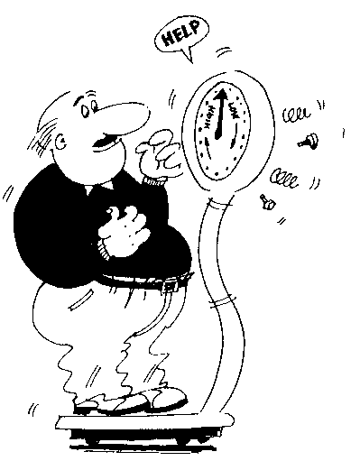

Fluid Overload.

This means that there is too much fluid in your body. If not resolved it raises your blood pressure, putting a strain on your heart and therefore increasing the risk of strokes and heart attacks.

Signs & Symptoms.

- Weight increase of at least 0.5 kilogram (or 1lb).
- Swollen ankles.
- Swollen fingers / tight rings.
- Puffy, swollen eyes (especially in the mornings).
- Breathlessness.
- Headache.

Not everyone will get all of the above symptoms.

Causes of Fluid Overload.

- Drinking too much fluid.
- Eating salty foods (which cause the body to retain fluid)
- Not draining out properly and therefore absorbing PD fluid into your system
- Not using enough strong 3.86% exchanges
- Not weighing or not altering your regime when necessary

Action.

If you are fluid overloaded you will need to take action to remove the excess fluid from your system and return to your dry weight. This is done in the following ways:

- Discuss concerns with healthcare worker.
- Using stronger fluid for your exchanges.
- Drinking less volume of fluid.
- Avoiding salty foods.

Glucose Removes Excess Fluid
Removes a lot more fluid
Removes slightly more fluid than 1.36%
Removes a little fluid

YE
1.36%
Glucose

Yellow or ‘Weak’ bag
2.27%
Glucose

Green or ‘medium’ bag
3.86%
Glucose

Orange or ‘strong’ bag

Dehydration.

This means that there is too little fluid in your body which will lead to low blood pressure which may cause you to feel dizzy, faint etc.

Signs & Symptoms.

- Weight loss of 0.5Kg (1lb) or more.
- Trim ankles.
- Cramps.
- Thirst.
- Dizziness or feeling faint.
- Nausea.
- May have “low drain” alarms whilst on the machine. (Beware that “low drain” alarms can also be caused by constipation).

Causes of Dehydration.

- Not drinking enough fluid.
- Using too many strong bags.
- Diarrhoea and/or vomiting.
- Sweating more than normal (hot weather/ sports / high temperature)
- Not weighing or not altering your regime when necessary

Action.

You need to replace the fluid in your body and resume your dry weight. This is done by:

- Discuss concerns with healthcare worker.
- Drinking an extra couple of drinks that day.
- Reducing the strength of your fluid.

Fluid Overload.
Light-headed/Dizzy
Thirst
Dry Skin.
Trim Ankles
Causes:-

- Not Drinking enough.
- Diarrhoea & Vomiting.
- Sweating a lot.
- Using to many strong bags
- High Body Temperature.
Action:-

- Drink more.
- Use 1.36% Exchanges.
Trim Ankles.

Dry / Target Weight.

As already mentioned, this is the weight at which you are fluid balanced i.e. not too much and not too little fluid in your body.

This weight however does not always stay the same as it will change depending on whether you gain or lose flesh weight. This weight change is a gradual one, for example 0.5kg over several days rather than overnight. As well as this gradual flesh weight change, you will notice your clothes becoming tighter/looser depending on whether you gain or lose weight.

Weighing yourself in the morning is advised.

Contamination.

If you touch the uncapped end of your miniset or if there is a hole in your catheter or minset:

- Do not drain in or out.
- Apply new minicap to miniset and apply white emergency clamp as close to the exit site as possible.
- Ring Ward 28N.

You will need to have a new miniset fitted and possibly a single dose of antibiotics.

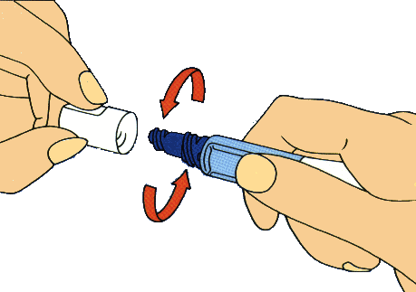

Remember: Do not touch dark area
with hands or clothing

Guide to Motor Insurance for dialysis patients

Motor Insurance.

Dialysis patients must inform their insurance companies that they are on dialysis.

Insurance companies sometimes raise premiums or refuse to insure dialysis patients. If you have any problems it is best to ask your present insurer or alternatively browse the Internet for alternative insurance companies.

Ordering of Stores.

Your delivery arrives from the company once a month on dates that the company will arrange for you. You will have this list of delivery dates and telephone call dates which precede each delivery in the back of the folder supplied by the company. The telephone call precedes the delivery by about a week.

Before this phone call you will need to count the stock items that you have left and tell the company when they phone. The company will then deliver enough items for you to use throughout the next month. If necessary the healthcare worker can help with this.

When the delivery arrives, you will need to check that the items issued are correct then sign the invoice. The delivery man will carry your supplies to wherever you keep them and will place the new items to the back so that you use up your oldest supplies first, unless of course they have the same expiry date.

If you are going to be out on your delivery day, please tell the company where to leave your supplies and they will advise the driver. Alternatively, you may find it more convenient to provide the company with a key which will be labelled with a code number and kept locked away between deliveries.

Please note if you are not in for your delivery and have not made alternative arrangements, the company will have to re-schedule your delivery at extra charge to the Renal Unit. The Renal Unit cannot sustain these additional costs.

NB. If you are running short of supplies please let us know. You can have whatever you need from the hospital but it is your responsibility to collect it.

Disposal of Rubbish

You can discard your dialysis bags / dressings in a black bag / bin with your usual household rubbish. You may need an extra bin or two in which case you ring the refuse department of your local council to request one. You should not be charged for this and you do not have to give your medical condition. Sharps boxes will need to be taken to your GP surgery.

Aftercare.

When you finish your PD training and go home, the nurses and doctors will need to monitor your progress and ensure that you are as well as possible as well as trying to prevent any complications and problems.

You will be asked to attend outpatients clinic on a regular 2 – 4 monthly basis which allows the doctors to examine you and make sure everything is running smoothly. In between clinic appointments the PD nurses will visit you at home.

You will also have an opportunity to discuss your progress in general and any problems or worries that you may be having. For safety reasons all PD staff carry personal safety alarms for travelling and community work. In between these visits you are able to contact the staff at any time of the day or night should you have an immediate problem.

Tests and Investigations.

Blood Tests.

These will be done regularly at clinics and sometimes at home visits. They are done for several reasons. e.g. To check waste product levels, tissue typing and to check for anaemia. The nurses or doctors will explain why they are being done on an individual basis, so just ask if you are unsure.

Swabs.

Swabs are taken generally to detect infection and which bacteria is causing it. This allows the doctors to prescribe the correct antibiotics. Routine swabbing takes place 3 monthly.

U.K.M.

This stands for Urea Kinetic Modelling and basically is a series of tests done over a 24 hour period which tells us whether or not you are having enough dialysis or not. It involves you collecting samples of urine and dialysis fluid and we will also take a blood sample. As a result of the U.K.M. testing, your PD regime may need to be changed.

This is done approximately six weeks after starting PD and every six months thereafter.

P.E.T.

This is a Peritoneal Equilibration Test and allows us to assess the nature of your particular peritoneal membrane. It involves you visiting the ward for approximately 1 hour while we perform an exchange and take a blood sample. We generally do this about 6 weeks after starting PD and it is repeated annually.

If UKM and PET indicate that you are not receiving enough dialysis, your regime will need to be altered. In some cases it may be necessary to transfer onto haemodialysis.

Lifestyle, Hobbies, Sex and Future

PD is something that you need to do to remain healthy and allow you to continue your life in your normal pattern but it shouldn't be allowed to take over your whole life.

It is advisable for everyone to maintain a regime of regular activity or exercise and as you begin to feel the benefit of PD hopefully you will be able to once again incorporate regular exercise in to your daily routine. As well as improving your general health, exercise will help to prevent constipation which may cause drainage problems.

The only activities to avoid are the ones which may pull or damage your catheter e.g., contact sports such as rugby or activities which put excess strain on your abdominal muscles e.g. weight lifting, otherwise most other activities are fine.

Initially you will probably be very aware of your catheter and line even though no-one else can see it under your clothing, but hopefully you will become accustomed to it and will be able to wear clothing such as shorts, T-shirts etc. without it being obvious.

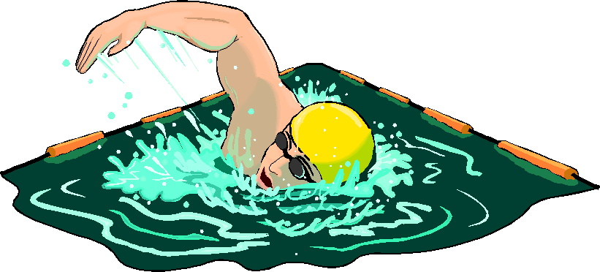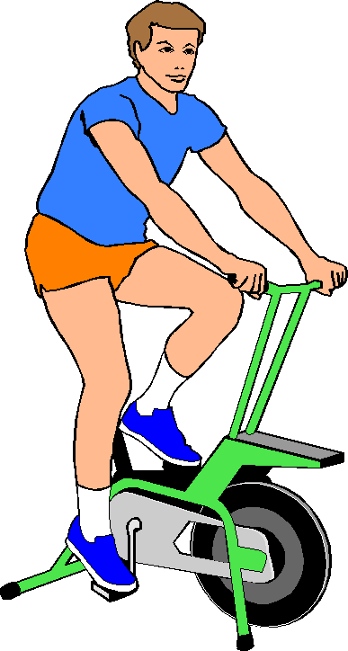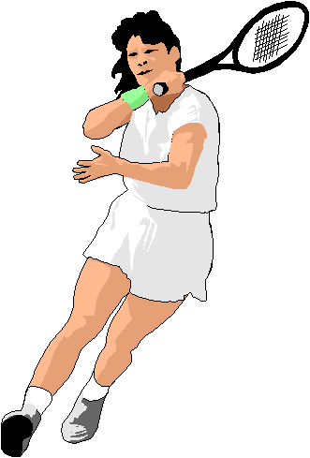
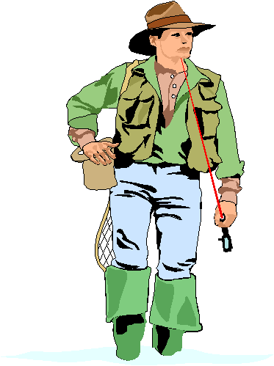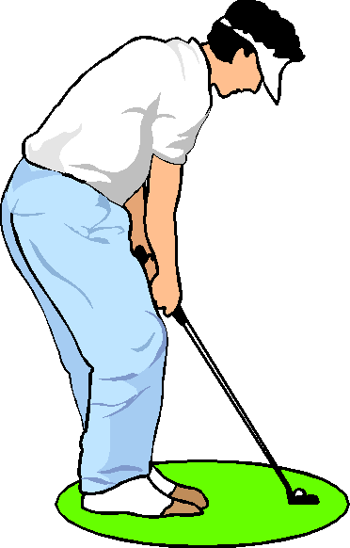

Kidney failure can sometimes have an effect on sexual activity and often reduces fertility. Often tiredness and lethargy caused by high levels of waste products in your bloodstream and/or anaemia can reduce sexual drive. This, together with the presence of the catheter and the side effects of certain drugs can disrupt your sex life. e.g. Certain anti-hypertensive (blood pressure drugs) can make men impotent. Communication between yourself and your partner is essential as they will also feel affected by the presence of the catheter and may be wary of hurting you, pulling the catheter etc. As long as the catheter is firmly taped down and cannot "pull" on the exit site it can be secured to your side, out of the way. Although fertility is usually reduced, contraception should still be used. You may notice some slight bloodstaining of your fluid after sexual intercourse, this is nothing to worry about and will resolve.

If you are experiencing problems in this, or any other area of your life don't bottle it up - discuss it with one of the nurses or doctors who may be able to help you or may suggest someone else who can help you. We have a Psychologist, Dr Rebecca Verling working with us who is happy to see patients who would benefit from her input. The PD nurses can refer you to her. People sometimes find that there may be difficulties for themselves and their families to adjust to a life on PD and discussing things with staff in confidence often helps.

A Peer Support Service is also available. Peer Support offers an opportunity to have a one to one chat and share personal experiences either face to face or over the telephone with an established kidney patient or carer. This service supports and compliments the care and education given by the healthcare team. If you would like to be put in touch with a Peer Supporter please discuss with staff.

Conclusion.

Now that you are able to manage PD and all it entails you will hopefully feel a lot less worried about the future and will even feel confident about returning to your usual lifestyle within the next few months.

There are several organisations you can contact for information and support.

The Shropshire and Mid Wales Kidney Patient Association is the local support group run by people who are, or have been, on dialysis or have had a transplant. Regular meetings provide opportunity for contact with local people. Their contact details are….

www.shropshire-midwales-kidney.org The group is affiliated to the National Kidney Federation whose Website who's contact details are……

The National Kidney Federation
6 Stanley Street
Worksop
Notts S81 7HX
Tel : 01909 487 795
Helpline : 0845 6010 209
Website : www.kidney.org.uk
Email : nkf@kidney.org.uk

There is a national group, the British Kidney Patients Association who on receipt of a £1.00 joining fee will send an information pack. Their contact details are….

British Kidney Patients Association
Bordon
Hants GU35 9JZ
Tel: 01420 472 021/2
Fax: 01420 475 831
Web: www.britishkidney-pa.co.uk
There are also various websites on the internet to gain information…….

www.nephroline.org
www.kidneywise.com
www.kidneyalliance.org.uk
www.cardiffandvale.wales.nhs.uk/main/kidneypatients/frameset/frameset.htm

It would be appreciated if you would take a few minutes to look back over your training time and answer the few questions that follow. This allows us a chance to evaluate the training programme and improve it for future PD patients.

Questionnaire.

- How did you feel about the pace of the training programme?

- How did you feel about the information that was taught to you?

- Was the information understandable ? too complicated? Necessary ? interesting ?

- Were you given enough practical help?

- How might the training programme be improved in your opinion?

Thank you for your response to these questions, please feel free to write overleaf should you have any other comments.

Author: Sr Gill Owen – Created: March 2010
Amended & Reviewed – September 2016 as follows:
Disposal of rubbish
Psychologist information added to Lifestyle, hobbies…
Peer Support information added to Lifestyle, hobbies…

