Dialysis
Information Manual

Information for Patients and Carers

Directorate of Medicine/Department of Nephrology

Dialysis Information Manual

Information for Patients and Carers

Contact Details 3
As CKD progresses… 4
Approaching Stage 5 CKD 5 Dialysis Therapy 6
Peritoneal Dialysis 6
Insertion of peritoneal dialysis catheter 7
PD (Continual Ambulatory Peritoneal Dialysis) 8
The exchanges 8
Equipment you need at home 9
Where to do the exchanges? 10
Training 10 Automated peritoneal dialysis 12
Assisted Automated Peritoneal Dialysis (AAPD) 13
Life on Peritoneal Dialysis 14
Haemodialysis 15
Access 16
Complications of HD 19
Holiday/travel 19
Conservative Care 20
What can I do to help myself? 21
Other information available 22
Chronic Kidney Disease Information Afternoons 23
What happens now? 24
Who can you ask for information and advice? 25
Other sources of information about health and Health care 25
You have been diagnosed as having Chronic Kidney Disease and you need careful management of this and may need treatments in the future. By giving you information about what may happen in the future, we aim to help you adapt to these treatments with as much help as possible. Your condition is monitored by a team of specialist health professionals which consists of:

- Medical team consisting of Consultant Nephrologists, Renal Registrars and Junior Doctors.

- Renal Dietician.

- Renal Social Worker.

- CKD Nurse and nursing colleagues.

- Access Nurse

- Transplant Co-ordinator

When you come to the renal clinic at the Royal Shrewsbury Hospital or Princess Royal Hospital you will meet most members of the team who will be monitoring and giving information about your condition and care. We have designed this booklet so you can record information about your condition, monitoring and treatments. We would like you to bring this booklet to clinics each time you attend. Should you have any questions or wish to discuss anything you are welcome to contact us on the telephone numbers below.

Consultant Nephrologist: Dr S P Davies
Secretary Tel No: 01743 261099

Consultant Nephrologist: Dr R Diwakar / Dr K S Eardley /
Dr S K Nair / Dr S Ramadoss
Secretary Tel No: 01743 261101

CKD Nurse: 01743 492583 1st contact
01743 261092 2nd contact

Vascular Access Nurse 01743 261055

Transplant Co-ordinators 01743 261039 / 261055 / 261092

Renal Dietician: 01743 261000 ext 1358

Integrated Care Services (ICS) Team: 01743 277699

Renal Unit 01743 261673

PD Suite 01743 261092 / 492583

As CKD progresses and level of kidney function drops it is necessary to plan ahead and start Renal Replacement Therapy (RRT) at the right time as this will reduce clinic risks, avoid you needing to be an in-patient in hospital and mean that you have a smoother transition to treatment.

When level of kidney function is around 20% (eGFR 20) kidney transplantation is considered and if this is a suitable option, you will be seen by the Transplant Nurse and begin the assessment process. Information about transplantation is in a separate booklet.

If kidney function level continues to decline towards 15% (eGFR 15) you need to understand about dialysis therapy to be able to make a decision about which treatment is the best for you.

APPROACHING STAGE 5 CKD
A
REFERRAL FOR FISTULA WHEN eGFR DROPPING –
NEED 6 MONTHS PRIOR TO ESTIMATION OF STARTING HD
CONTINUE EDUCATION ABOUT OPTIONS OF DIALYSIS OR CONSERVATIVE MANAGEMENT
DECISION ABOUT DIALYSIS WHEN eGFR 15
1ST OPTION – PD
2ND OPTION – HHD
3RD OPTION – HOSPITAL HD

REFERRAL FOR CATHETER INSERTION WHEN SYMPTOMS MEAN DIALYSIS NEEDS TO START
KIDNEY FUNCTION (eGFR) ABOUT 20% -
CONSIDERATION OF SUITABILITY FOR KIDNEY TRANSPLANT

NO

YES
REFERRED TO TRANSPLANT SISTER
CONSERVATIVE MANAGEMENT

PD

HD

Dialysis Therapy

As your kidneys fail dialysis treatment will be started as appropriate. Dialysis is a process of removing waste products and fluid from your body. There are two types of Dialysis:-

- Peritoneal Dialysis
- Haemodialysis

Peritoneal Dialysis

Inside everyone's abdominal cavity is a membrane called a peritoneum. It has a good blood supply and forms a lining to your abdomen.

When you are on Peritoneal Dialysis (PD for short) we drain fluid into your abdominal cavity. The fluid stays there all the time while you are continuing with your normal daily activities.

While the fluid is inside your abdominal cavity waste products and excess fluid are drawn from your blood stream, through the peritoneum, into the fluid itself. This process goes on continuously.

After several hours the fluid has removed as many waste products and excess fluid as it can, therefore it needs to be drained out and fresh fluid put in to allow the process to continue. This is called an 'exchange'.

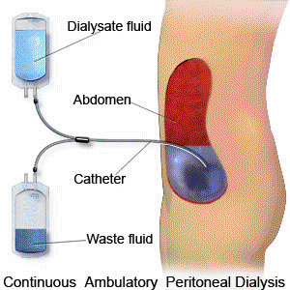
To be able to drain fluid in and out of your abdominal cavity you need to have a small flexible tube called a 'catheter' in place. One end sits inside your abdominal cavity and the other end is outside your body.

There are 3 types of peritoneal dialysis

- PD (continuous ambulatory peritoneal dialysis)

- APD (automated peritoneal dialysis)

- AAPD (assisted automated peritoneal dialysis)

Insertion of the Peritoneal Dialysis Catheter

When the time comes for you to start peritoneal dialysis the first step is to have the catheter inserted and this is done at the Royal Shrewsbury Hospital.

You will have had a swab taken from your nose and groin and if this shows particular bacteria on your skin or in your nose, we will give you an antibacterial soap to wash with for a few days before the procedure and / or some ointment to put just inside your nostrils. You will also be given intravenous antibiotics prior to the procedure.

The catheter is inserted during an operation, usually under a general anaesthetic.

If you are well enough and have someone to stay with you at home after the operation, it can be done on the Day Surgery Unit at the Royal Shrewsbury Hospital.

If you have a lot of symptoms or you have no one to stay with you overnight after the operation, you will need to be admitted into hospital overnight.

When the catheter is in place and as long as there are no complications, you can go home. Ideally, the catheter should be left unused for 10 – 14 days to allow your body to heal but we will see you once or twice during that time to check your dressings and take bloods for your waste product levels.

After the catheter has been inserted you are advised not to drive, lift heavy objects or have sex for 2 weeks. The PD staff will fully explain these instructions at the time.

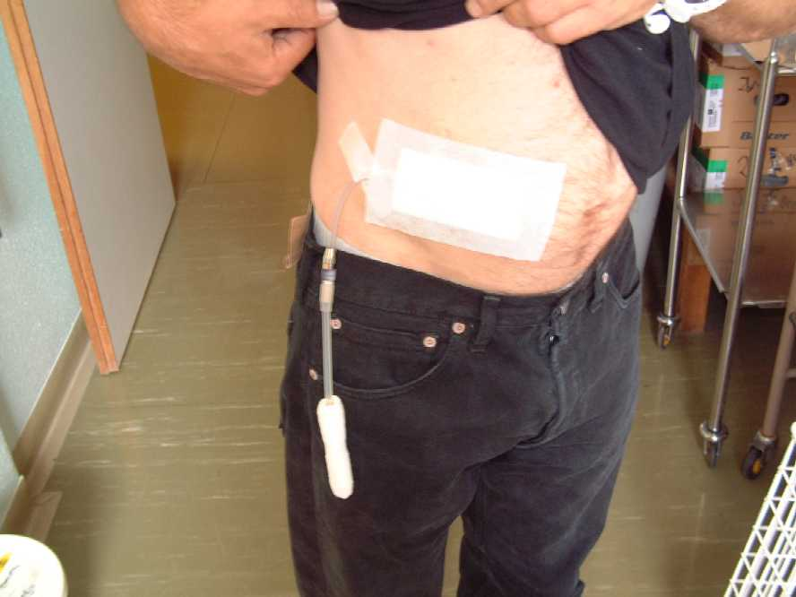
Picture showing peritoneal dialysis catheter

PD (Continuous Ambulatory Peritoneal Dialysis)

This is a treatment that is carried out at home which you do yourself. As explained the fluid inside your abdominal cavity needs to be drained out and fresh fluid drained in to allow the waste product and fluid removal to continue. This is an exchange and you will need to do 4 exchanges every day.

The exchanges

You can see a demonstration of an exchange at a home or hospital visit.

It takes about half an hour from start to finish. The fluid needs to be inside your abdomen for a minimum of 3 hours and as long as you do 4 each day the time you do the exchanges is flexible.

You do not have to stick rigidly to certain times. This is important when planning your day's activity.

The equipment you need at home will be:

A surface – a clean, smooth surface, ideally melamine or formica.

A bin – to collect clinical waste.

Scissors – Just for use with your CAPD.

A hook – To use to hang the bag up to drain the fluid in.

Liquid soap – to use for hand wash.

Scales – to weigh yourself daily.

The nurses will be able to show you photographs and examples of this equipment.

All other supplies are delivered once a month. This includes the bags of fluid, dressings for your catheter, alcohol hand cleanser etc. Storage space will be needed for all this equipment and if it is not available inside then a garage or shed is fine – as long as the stock stays dry.

All waste from the dialysis is disposed of in general household collections. You may need a second wheelie bin from the Council.

Where to do the exchanges?

Most people have an area in their homes that they have a surface, chair etc to carry out their treatment and we recommend that this is in a bedroom.

However, it is possible to carry out exchanges elsewhere – at work, other places, in the car etc, so most activities are possible.

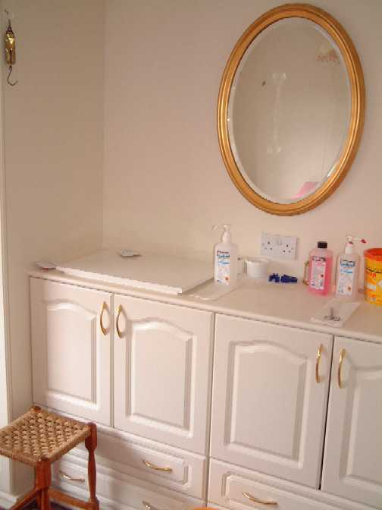

Picture showing typical bedroom, suitable for PD

Training

When your catheter has been inserted and ideally healed over 10 – 14 days it will be used to drain fluid in and out of your abdomen to start the process of dialysis.

As you will be carrying out this treatment at home, you will be given full training by the PD nurses. They will teach you how to carry out the exchanges, how to look after your catheter, how to recognise if you have a problem and what to do about it etc.

The training takes about a week on average. If you are well enough, it may be done at your home or you could come to the Royal Shrewsbury Hospital on a daily basis. If you are unwell, you may need to be an in patient at the Royal Shrewsbury Hospital.

The training is done on an individual basis and is taken at your own pace. When you feel ready to start carrying out your exchanges at home and the medical and nursing teams feel you are ready, then the PD nurses will set you up at home.

You will be visited several times by the PD nurses over the next few weeks to make sure everything is running smoothly. As you settle down on CAPD the home visits become monthly.
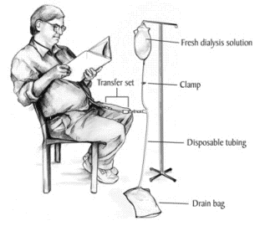

Automated Peritoneal Dialysis

There is another form of PD called automated peritoneal dialysis (APD for short), which most people have. It works in exactly the same way in that you have a catheter in your abdomen and drain fluid in and out. But instead of doing 4 exchanges every day you connect yourself to a machine at night and whilst you sleep, the machine drains fluid in and out of your abdomen through your catheter. This effectively does the exchanges for you at night and leaves most of the day free from exchanges.

Some people change onto APD after a few weeks on CAPD if they need more dialysis or the routine of APD allows them to continue to go to work.

Picture showing an Automated Peritoneal Dialysis (APD) machine
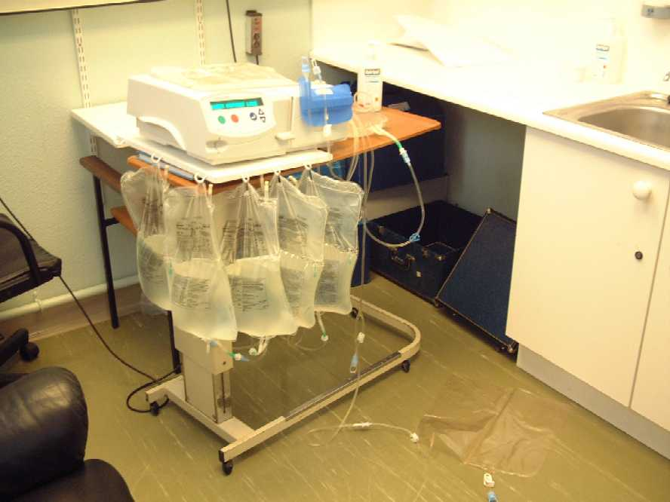

Assisted Automated Peritoneal Dialysis (AAPD)

This is when a healthcare professional visits daily to set up the APD machine. When you go to bed, you will just need to connect yourself to the machine and run the therapy overnight.

This will be a good option for people who prefer to have their treatment at home, but feel initially that they may not be able to manage the therapy independently.

Complications
Sometimes the catheter doesn’t allow good flows in and out and may need to be replaced.

There is also the risk of technique failure which means there is a 50% risk of technique failure needing you to switch to Haemodialysis after 2 years.

There is a risk of developing a hernia due to the increased pressure within the abdomen.

Encapsulating Peritoneal Sclerosis is a rare complication, which may develop during or after stopping PD.

The biggest risk of peritoneal dialysis is infection. Having a catheter in your abdomen is a risk in itself and draining fluid into your abdomen four times daily increases the infection risk even more.

During the training period, the PD team will teach you how to cut down the risk of infection as much as possible.

Follow-up & Support

There is good support available when you have started PD. The nurses will be guiding you to manage your treatment independently. However, you will always be monitored medically at out-patients clinics as well as having routine home visits to offer support and further guidance. Help is always available 24 hours daily should you run into problems.

Life on Peritoneal Dialysis

When you start on PD it will be an unsettling time for you and your family. As you gain confidence in managing your treatment, you are encouraged to resume all the activities you did before.

Work, travel, holidays, hobbies, sports etc are perfectly possible. The only activities that are discouraged are ones that may damage your catheter or abdomen e.g. heavy contact sports such as rugby, wrestling etc.

It is a matter of carrying out your exchanges to fit around your activities. Exchanges can be done in the car or in other buildings. If you want a few days away – the fluid can be taken with you. If you want a longer holiday – the company can deliver your supplies to most countries in the world.

Haemodialysis

This treatment removes waste products and excess fluid from your body. During a haemodialysis session a small amount of blood is removed from your body and passed through an artificial kidney attached to a machine. The waste products and fluid are removed then the blood is passed back into your body.

The haemodialysis treatment can be:

Home Haemodialysis – We encourage you to do home haemodialysis if possible, as there are benefits to carrying out your haemodialysis at home.

Increased dialysis time which means you can usually eat and drink more.

Flexibility of treatment times which is a huge benefit to most people allowing work, travel, holiday etc more easily.

Reduced visits to hospital.

Minimal Care Hospital Haemodialysis – Treatment carried out in Hospital but you are involved in carrying out your own treatment, allowing a bit more flexibility.

Hospital Based Haemodialysis – 3 times weekly for 4 hours on average.

You need to come into the Renal Unit 3 times every week. When in the Unit you sit in an armchair connected to the haemodialysis machine and the dialysis process continues for about 4 hours. During this time, you can read, watch television, chat to other people, listen to the radio or have 40 winks. You may have a relative or friend with you if you wish it.

The HD facilities are at the Royal Shrewsbury Hospital as well as at Princess Royal Hospital. Transport is available to take you in for HD and then home afterwards. However, a lot of people prefer to drive themselves in and out as this gives more flexibility and less “waiting” time.

Please note that we are unable to guarantee that you can dialyse at the Renal Unit of your choice, or at the timeslots of your choice. We have used haemodialysis facilities at Cannock and Walsall in the past and may need to use these facilities again.

Powys patients may need to have their haemodialysis at Wrexham if there are no spaces at Royal Shrewsbury Hospital Renal Unit (unless they can do a twilight shift).

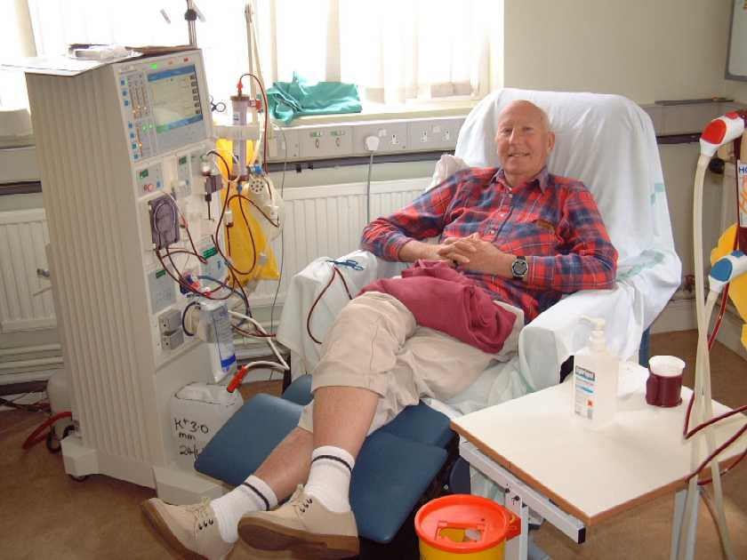
Picture showing person having haemodialysis

When you are on haemodialysis you will probably need to continue with some dietary restrictions. Usually people have to watch how much fluid is drunk in 24 hours and your intake may need to be restricted.

The dietician and renal staff will be able to advise you of your individual needs.

Access

To be able to be connected to the machine, you will need to have a fistula formed. This means a small operation in your forearm. Two blood vessels are joined together and this causes the vessels to enlarge and therefore contain more blood. During the haemodialysis session the nurses will put two needles into your fistula, then attach them to tubing to allow the blood to flow out of your arm, through the artificial kidney (which is where the waste products and fluid is removed) then back into your arm through the second needle.

Once you have had the operation to form your fistula it takes about 3 months for the blood vessels to mature. During this time the fistula cannot be 'used' for dialysis, so if you need treatment, temporary access is needed until the fistula is ready.

Picture showing Arterio – venous fistula (AVF) in use

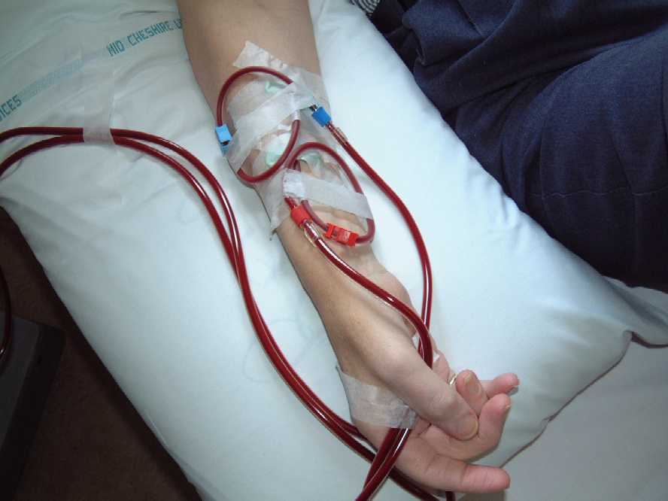

Some patients are dialysed using a ‘neckline’. This means having a small tube put into one of the blood vessels in your neck or in your groin. The tube is there for several weeks and is used to connect you to the haemodialysis machine for the treatment. When your fistula is ready to use, the temporary access will be removed.

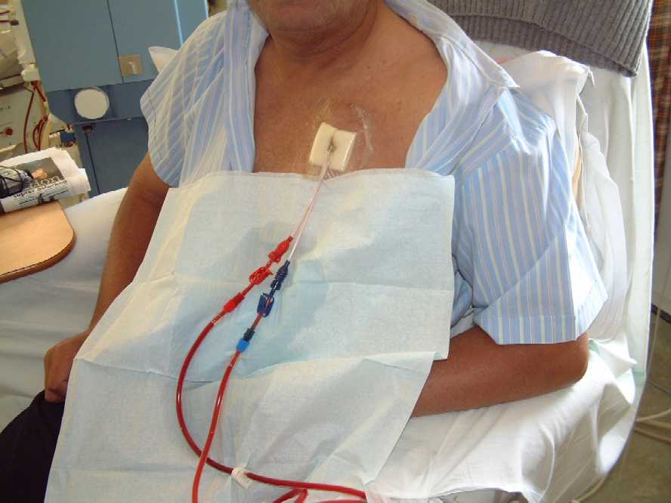
Picture showing tunnelled ‘neckline’

Complications of HD

Risk of infection from vascular access, particularly necklines. This can lead to infections within the heart valves or spine and joints.

Risk of technique failure needing to switch to PD.

Risk of bleeding complications from regular use of anticoagulants during HD.

Holidays / Travel

When on haemodialysis, travel and holidays are possible. There is usually a 2 day break between haemodialysis sessions which can be used for short breaks. If you want to go away for longer, it would need to be planned to include haemodialysis treatment at a different unit. This would need to be organised before hand but is quite possible at units in this country or abroad.

Conservative care

Some patients after considering all the options decide that they do not want to be considered for dialysis therapy should their kidneys completely fail. This may or may not be a very difficult decision for you to come to, but it should be made after you have considered all of the options and implications of this decision thoroughly. Your decision will however be fully supported.

The aim of your hospital and community Doctors, Nurses, dieticians, social workers etc will still be to slow the progression of your kidney disease and to minimise the symptoms associated with kidney failure.

We will also arrange support for you and your family should you become more frail. It is also an option when people may decide to finish dialysis.

In this situation, a person may be approaching the end of their life. This will be discussed in more detail if this option is taken using a document called Preferred Priorities of Care (PPC) which help us support you living well until end of life.

If you choose not to have dialysis, your kidney function will continue to be monitored regularly and the doctors will continue to keep your kidneys going as long as possible. If you begin to get symptoms from the build-up of waste products and fluid, we will try to reduce them with medications and may refer you to the Palliative Care Team to help with symptom management.

What can you do to help yourself

You are part of the team of people managing and monitoring your kidney failure. To ensure you are doing the most to help yourself you need to:-

- Attend clinic for regular review by consultant.

- Take medications as prescribed by the doctors. Do not stop without discussing with doctors first. If you do not fully understand the medication regime, please ask us.

- Try to improve your general health and fitness. Dieticians can advise on losing a little weight if you are overweight and adapting to a healthier diet. Ideal BMI 20 – 25

Adding in some daily activity and / or exercise will improve your blood pressure and hopefully make you feel better. It doesn’t need to be a sport – walking for 20 – 30 minutes daily will help!

- Try to give up smoking if you are a smoker. This will improve your blood pressure, lungs and bank balance! See the practice nurse at your GP surgery for more help and support – Good luck.
NHS Free Helpline 0800 0224 332
Help available of website www.nhs.uk/gosmokefree

- Avoid harmful drugs – always check with Pharmacist / GP. Avoid anti-inflammatory pain-killers (e.g. Ibuprofen, Voltorol).

- Avoid dehydration. Drink 1 ½ - 2 litres fluid daily. If you have diarrhoea / vomiting some medication may need to be stopped. See your doctor.

- Seek early treatment. If you suspect you have an infection, particularly urine infection / cystitis.

- Bring this booklet with you to each Out-Patient and GP appointment.

- Contact us if you feel your symptoms are worsening.

Other Information Available
There are several organisations you can contact for information and / or support.

Renal Patient View – www.patientview.org
You can create an account on this website and can look at your own blood results and get a lot of information about kidney disease and options of dialysis, transplantation and conservative management.
You will need to fill in and sign an enrolment form to give your permission for the hospital to release your blood results to the Website. Please ask a member of staff to help you if you need assistance with this.

The Shropshire & Mid Wales Kidney Patient Association is the local support group run by people who are or have been on dialysis or who have had transplants. Regular meetings and newsletters provide opportunity for contact with local people. The group is affiliated to The National Kidney Federation and are an organisation providing support and information to people with kidney failure.

The National Kidney Federation
6 Stanley Street, Worksop, Notts, S81 7HX.
Tel No: 01909 487795 Helpline: 08456 010 209
Web site: www.kidney.org.uk Email: nkf@kidney.org.uk

British Kidney Patient Association
01420 541 424 - Support Line
01420 894 438 - Fax info@britishkidney-patient.co.uk

www.nephronline.org www.kidneywise.org

The National Kidney Research Fund
Kings Chambers
Priestgate
Peterborough
PE1 1FG
Tel. 01733 704650
Website. www.nkrf.org.uk

National Kidney Federation
www.kidney.org.uk www.kidneyalliance.org.uk

Kidney Patients Library
www.cardiffandvale.wales.nhs.uk/main/kidneypatients/frameset/frameset.htm

Renal Info – support and resources for people with kidney disease
www.renalinfo.com

www.kidneypatientguide.org.uk

Chronic Kidney Disease Information Afternoons are organised every 1 – 2 months and are held at the Royal Shrewsbury Hospital in the Hamar Centre.

This provides opportunity for you to see and meet other people who have been diagnosed with kidney failure and are coming up for dialysis. There may be other people who are on dialysis or who have had transplants. It is an informal occasion with opportunity to chat over a cup of tea if you want to or just get information. An invitation will be sent to you for the next one. It is strongly advised that you come to one or more of these sessions to gain more information about dialysis and transplants.

What happens now?
Hopefully you feel you are beginning to understand the situation you are in and what will happen when the time comes for you to start treatment. If you feel you need further home visits or more information, please contact the Community Dialysis Team on 01743 492583 or 261092.

You will continue to be monitored at clinics. You will usually see the Dietician and CKD nurse there also, to be able to ask questions or just chat.

If you have any particular worries in-between clinic appointments please ring up and a home visit by the CKD nurse can be arranged.

Although you understand the situation, it may make you feel shocked and upset. People cope with these feelings in different ways, but help and support is available from health professionals and other people who have been in the same situation as you and are willing to chat and give support.

If you feel that you want someone to discuss these issues with you in more detail, counselling services can be organised through the GP or renal social worker.

When the time comes to start treatment it may be a time that you and your family feel unsettled and it will probably be several weeks until you feel that you are getting used to the routines of treatment.

Hopefully, having this information and support before you start will make this time a little easier.

Author: Sister Elaine Gibson, June 10
Adapted from the Chronic Kidney Disease Information Disease June 09
Contact details updated: 14/04/14
Contact details and conservative care section updated: 28/10/14
Contact details updated 29/12/15
Updated contact details, HHD info & added Patient View info: September 2016
Titled changed from Renal Replacement Therapy… to Dialysis Information Manual – 11/01/16

Who can you ask for information and advice?

You can get further advice and information by:
Asking the Ward Sister or Clinical Nurse Manager
Visiting or contacting the Patient Advice and Liaison Service (PALS). PALS will act on your behalf when handling patient and family concerns. They can also help you get support from other local or national agencies. PALS, is a confidential service.
Royal Shrewsbury Hospital Tel: 0800 783 0057 or
Tel: 01743 261691
Princess Royal Hospital Tel: 01952 282888

Other sources of information about health and health care:
NHS Direct is a nurse-led advice service run by the NHS for patients with questions about diagnosis and treatment of common conditions.
Telephone: 0845 4647
Website: www.nhsdirect.nhs.uk
Equip is a website established by the NHS in the West Midlands. It signposts patients to quality health information and provides local information about support groups and contacts.
Website: www.equip.nhs.uk
NHS Choices has been developed to help you make choices about your health, from lifestyle decisions about things like smoking, drinking and exercise, through to the practical aspects of finding and using NHS services when you need them.
Website: www.nhs.uk

This leaflet is provided for your information only. It must not be used as a substitute for professional medical care by a qualified doctor or other health care professional. Always check with your doctor if you have any concerns about your condition or treatment. The Shrewsbury and Telford Hospital NHS Trust is not responsible or liable, directly or indirectly, for ANY form of damages whatsoever resulting from the use (or misuse) of information contained in this leaflet or found on web pages linked to by this leaflet.
Information Produced by: Directorate of Medicine/Department of Nephrology.

© The Shrewsbury and Telford Hospital NHS Trust, www.sath.nhs.uk

