Who can you ask for information and advice?
Visiting or contacting the Patient Advice and Liaison Service (PALS). PALS will act on your behalf when handling patient and family concerns. They can also help you get support from other local or national agencies. PALS, is a confidential service.

Royal Shrewsbury Hospital
01743 261691
0800 783 0057
An answerphone will take out-of-hours messages

Princess Royal Hospital
01952 282888
01952 641222 ext: 4382
An answerphone will take out-of-hours messages

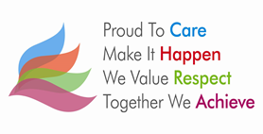

July 2016
Review: July 2017
Information Produced by: Julie Cooper, Renal Access Nurse
©The Shrewsbury and Telford Hospital NHS Trust, www.sath.nhs.uk

Renal Vascular Access

Patients guide to caring for your Haemodialysis Catheter

