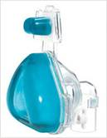

Dialysis at Home

Introduction
If you have chronic kidney disease there are a number of self-care treatment choices that may be for you:

- Continuous ambulatory peritoneal dialysis (CAPD)
- Automated peritoneal dialysis
- Home Haemodialysis
- Shared Care haemodialysis in the renal unit

This leaflet provides information of our well established home dialysis programme and gives answers to some of the most frequently asked questions. There are separate information leaflets for Shared care (complete some or all tasks of your treatment in centre) and CAPD.

What is the Home Dialysis programme?
Patients who receive dialysis either in the hospital setting or a satellite unit will need to attend three times a week for four hours each session. You will be allocated a slot; due to the busy nature of the units we cannot grantee a pacific time to when your bed is ready and when a nurse is available to put you on the machine. If you meet the criteria for transport additional should be allowed time waiting for collection, often the route to the unit is not direct and waiting for collection can take a number of hours. This can mean several hours of your day are taken up to receive your treatment.

Home Dialysis will ensure you will have more control and flexibility over your schedule, you can decide which days and at what time you have your treatment. You can fit your treatment around your busy work and social life. There is also the option to increase the number of sessions per week and reducing the amount of hours on the machine. This can often lead to a better quality of life, reducing restrictions of your renal fluid and food diet.

Benefits of Home Dialysis

- No waiting times
- Better acceptance and understanding of your treatment
- Weekends away
- Freedom and flexibility

- More control of your health needs
- Improved satisfaction
- Possibility of reducing your medication
- Having your treatment in your home setting

Will I receive training?
YES. Each patient will receive a training handbook which will be placed in your profile at the unit. This identifies what you are learning, at what stage and tracks your progress. Your treatment is broken down into 14 tasks, each task is required to be signed off by a qualified nurse and yourself before you are able to independently complete the task without supervision. Training can take from 6 to 12 weeks, however we tailor the training to your needs, if you require more time to achieve the tasks on your own we will give additional support and time to achieve your goal of Home Dialysis.

Who can train?
We promote the patient having the treatment to be as independent as possible in doing the treatment for themselves. We also encourage a carer, spouse and family members to assist if necessary and are welcomed to attend sessions on the unit to learn how to do parts or all the treatment themselves. We know Home Dialysis is the best setting for your treatment and you may not be able to do all or any of the tasks yourself. Training will be offered to the spouse, partner or family member who will be delivering the treatment at home, we just ask that they are committed to attending the training sessions at the unit.

I live on my own, can I do Home Dialysis?
At Heart of England Foundation Trust we offer Solo Home Dialysis. You have to meet a certain criteria to be offered Solo. Listed below are some of the considerations we make:

- Assessed if you are stable on haemodialysis
- Your case will discussed at the Home Therapies Meeting
- Compliant to renal food and fluid diet restrictions
- Other health complications
- Compliance to your treatment

You will require a person such as a family member, friend or neighbour who if you felt unwell during your treatment could come round to help if necessary. A key safe would also be needed to be installed and a telephone land line which has speed dial numbers programed into it.

You would require additional time of independence spent on the unit prior to going home. The Shared Care Stephanie Walker and Home Sister Susan Handley would both do independent assessments.

What support do I get?
There is a dedicated team of staff who will support you at home. Sister Susan Handley the Home Dialysis sister will be your first contact of support.

- First session at home a member of the team will be present throughout the whole treatment
- Second and third treatment you will be visited by the Home Dialysis team
- Second to Fourth week; once a week visit from the Home Dialysis team
- Once a month visit from Home Dialysis team
- If you require further support or require a visit you can contact Sister Handley to arrange a time and date.

You will be given a list further contact numbers that you may require such as Holiday coordinator, access, technical support, Homecare team and unit numbers. Your monthly bloods will be reviewed and your case will be discussed in the Multidisciplinary team meeting who will monitor, change if required and discuss aspects of your treatment.

If you require Intravenous Iron you will need to attend one of the units to receive this and complete your session/sessions at that unit. If you have issues with your fistula (access), graft or permcath you may need to attend one of the units for this to be assessed while on the machine.

What equipment will I need at home?
Extra equipment is required; the hospital will arrange plumbing and installation of the machine. You will have a stock delivered every month which you will be required to store. Patients will often store it in a shed, garage, and cupboard or in the room the machine is in.

You are interested in Home Dialysis what happens now?
- Referred to the Home Dialysis Team
- A home assessment will be booked
- Training will commence
- Home Dialysis team will track your progress
- Plumbing installation will be booked
- Tracking progress we set a start date for Home Dialysis
- Home prescription is signed by the consultant
- We order your first month stock
- Refer you to the Home care team if you are on an injection called epo
- Final assessment to ensure you are fully trained
- Independently you will deliver treatment yourself or a dedicated person at the unit.
- Confirmation of home date
- Installation of the equipment

You will still be required to attend your renal clinics and hospital appointments.

If Home dialysis is not for you but would still like to be involved in your treatment we can offer you the option of Shared Care. Shared Care is you and the staff working together, to participate in your treatment if you require extra support we are here to help. All we require is your willingness to learn and be involved in your treatment. Ask for the Shared Care information leaflet.

If you would like further information please ask a member of staff on the unit and they can refer you to the Home Therapies team.

If you have any questions please call the Home Sister or the Shared Care Sister

Renal contact details:
Home Sister Sue Handley 07974972606
Shared Care Sister 07772141981
Glaxo Renal Unit 0121 424 1160

Contact us:
If you would like more information about your condition, please speak to your named nurse, key worker, or Social Worker, or the Home Dialysis Sister for any further details and contacts. 01420472021.

The BKPA (British Kidney Patient Association) help support patients and their families with aids and finances.

The National Kidney Federation is a nationwide support group and resource for information, address NKF. 08456010209.

Our commitment to confidentiality
We keep personal and clinical information about you to ensure you receive appropriate care and treatment. Everyone working in the NHS has a legal duty to keep information about you confidential.

We will share information with other parts of the NHS to support your healthcare needs, and we will inform your GP of your progress unless you ask us not to. If we need to share information that identifies you with other organisations we will ask for your consent. You can help us by pointing out any information in your records which is wrong or needs updating.

Additional Sources of Information:
Go online and view NHS Choices website for more information about a wide range of health topics http://www.nhs.uk/Pages/HomePage.aspx

You may want to visit one of our Health Information Centres located in:

- Main Entrance at Birmingham Heartlands Hospital Tel: 0121 424 2280
- Treatment Centre at Good Hope Hospital Tel: 0121 424 9946
- Clinic Entrance Solihull Hospital Tel: 0121 424 5616
or contact us by email: healthinfo.centre@heartofengland.nhs.uk.

Dear Patient
We welcome your views on what you thought of this patient information leaflet, also any suggestions on how you feel we can improve through our feedback link below:

- Patient Information Feedback email: patientinformationleafletfeedback@heartofengland.nhs.uk

If you wish to make any other comments this can be done through the links listed below:

- Patient Opinion: www.patientopinion.org.uk
- I want great care: www.iwantgreatcare.org (Here you can leave feedback about your doctor)

Be helpful and respectful: think about what people might want to know about our patient information and this hospital and how your experiences might benefit others. Remember your words must be polite and respectful, and you cannot name individuals on the sites.

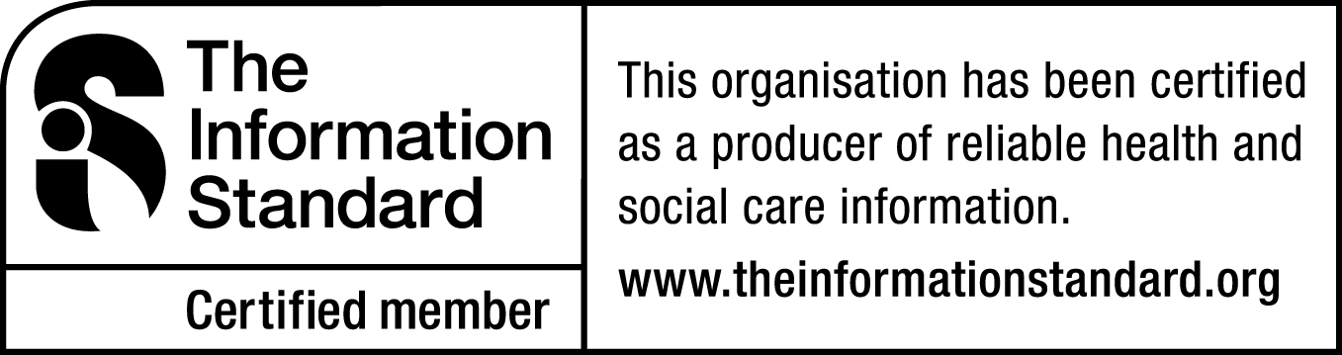
If you have any questions you may want to ask about your condition or your treatment or if there is anything you do not understand and you wish to know more about please write them down and your doctor will be more than happy to try and answer them for you.

